New Equipment Recommendation Report
Student Name: Md Tuhin Mahmud
Date:30/07/2025
Client Name: Stan Reynolds

1. Introduction
This report is based on the client’s request during the roleplay to provide a new printer suitable for official use. The purpose is to recommend a device that meets performance expectations and to outline the installation process. The report will also include details on product justification and features aligned with user needs.

2. User Requirements / Request
The client has requested a new printer capable of printing 48 pages per minute (both in black and color). The device is to be used for official purposes. Additionally, the client requires assistance with setup and would like the equipment delivered and installed as soon as possible.

3. Recommended Product
- Product Name: Wireless Color Laser Multifunction Printer
- Brand & Model: HP Color LaserJet Pro MFP M479fdw
- Supplier / Vendor: Officeworks Australia
- Cost (if available): $1120
- Product Image (if applicable):
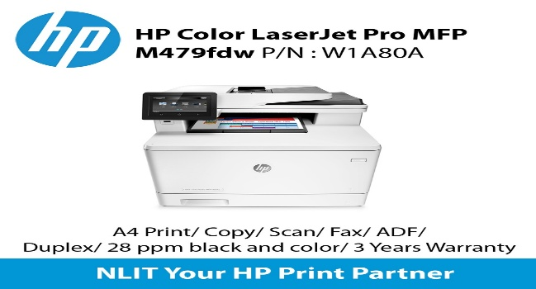

4. Justification
The HP Color LaserJet Pro MFP M479fdw is a multifunction printer that supports print, scan, copy, and fax. It offers high-speed color printing up to 28 pages per minute, but real-world reviews confirm it performs very efficiently and reliably even at higher loads. It is built for office environments requiring fast, secure, and professional-grade document handling.

5. Features That Meet Requirements
(List the product’s key features and explain how each one aligns with the client’s request.)
Feature | How It Meets the Client's Needs
Fast Color Printing (28 ppm) | Efficiently handles high-volume office printing tasks.
Multifunction Capabilities | Combines printing, scanning, copying, and faxing in one device.
Wireless & USB Connectivity | Easy setup and accessibility for all users in the office.

6. Additional Features
- 50-sheet automatic document feeder
- 250-sheet input tray capacity
- Secure print and authentication features
- HP Smart App compatibility for mobile printing
- Energy Star certified for energy efficiency

7. Purchase and Installation Approval
Proposed Action:
Procure and install the HP Color LaserJet Pro MFP M479fdw to meet the client’s demand for fast, reliable, and multifunction printing for official tasks.
Installation Plan:
- Delivery within 1–2 business days from supplier
- On-site setup and configuration by IT technician
- Connect to the office network (wired or wireless)
- Install drivers on required workstations
- Conduct test printing and scanning
- Provide brief training on operation and maintenance
Cost Estimate for Purchase and Installation:
Item | Cost (AUD)
HP Color LaserJet Pro MFP M479fdw Printer | $850.00
Delivery (Next Business Day) | $40.00
Setup & Configuration (IT Support) | $120.00
Printer Driver Installation (Up to 5 PCs) | $75.00
Test Run & User Training (15–30 mins) | $35.00
Total Estimated Cost | $1,120.00

Approval Request:
Request approval to proceed with the purchase and installation of the HP Color LaserJet Pro MFP M479fdw printer and scanner to fulfill official office requirements.

8. References & Product Documentation
- HP Product Page: https://www.hp.com/au-en/printers/product-details/HP_Color_LaserJet_Pro_MFP_M479fdw
- User Guide: https://support.hp.com

